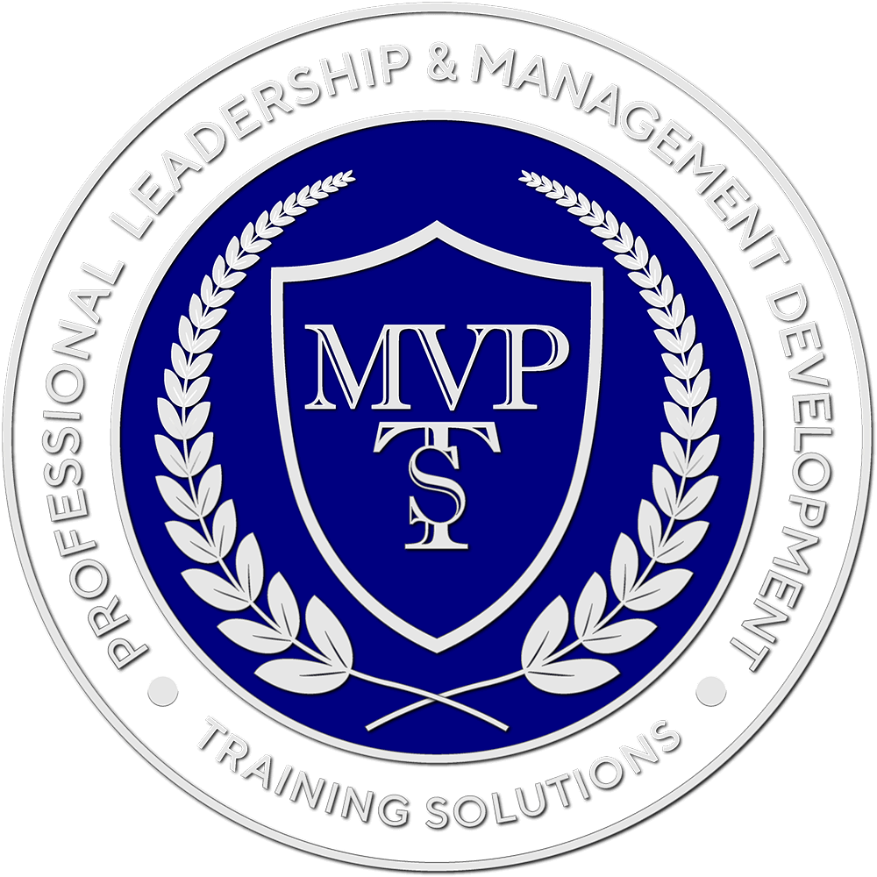
The Cloud and Business
In this book, you'll learn about cloud computing, explore various business models, understand the advantages and risks, address security concerns, manage devices, and delve into service-oriented architecture. You'll also examine business processes, standards, and monitoring practices essential for effective cloud implementation.
eBook URL:
https://online.fliphtml5.com/beung/bujb/
QR Code:

Password:
TCAB2024

